Assessment Team Report

The Assessment Team comprised of following three members visited the Department of Livestock Management on November 15, 2012 in order to assess its M.Sc (Hons) degree program:

- Prof. Dr. Sohail Akhtar Convener AT
- Prof. Dr. Sohail Ahmad AT Member
- Dr. Naila Chand External AT Member

The above team in its meeting with the Program team, QEC officials, Dean and Chairman, identified the following Strength and Weaknesses of the program:

Strengths:

- The current teaching staff is well- qualified. There are three Professors, two Associate Professors, three Assistant Professors and three Lecturers.

- The department has five well-equipped research laboratories for students.

- The department has one computer laboratory.

- Classes are being taught regularly and course contents are completed within the stipulated period.

Weaknesses:

- The curriculum is not revised for a last five years.

- Labs and Farms are not containing sufficient resources. For example: lack of local generic and resources like buffaloes, sheep and camel etc.
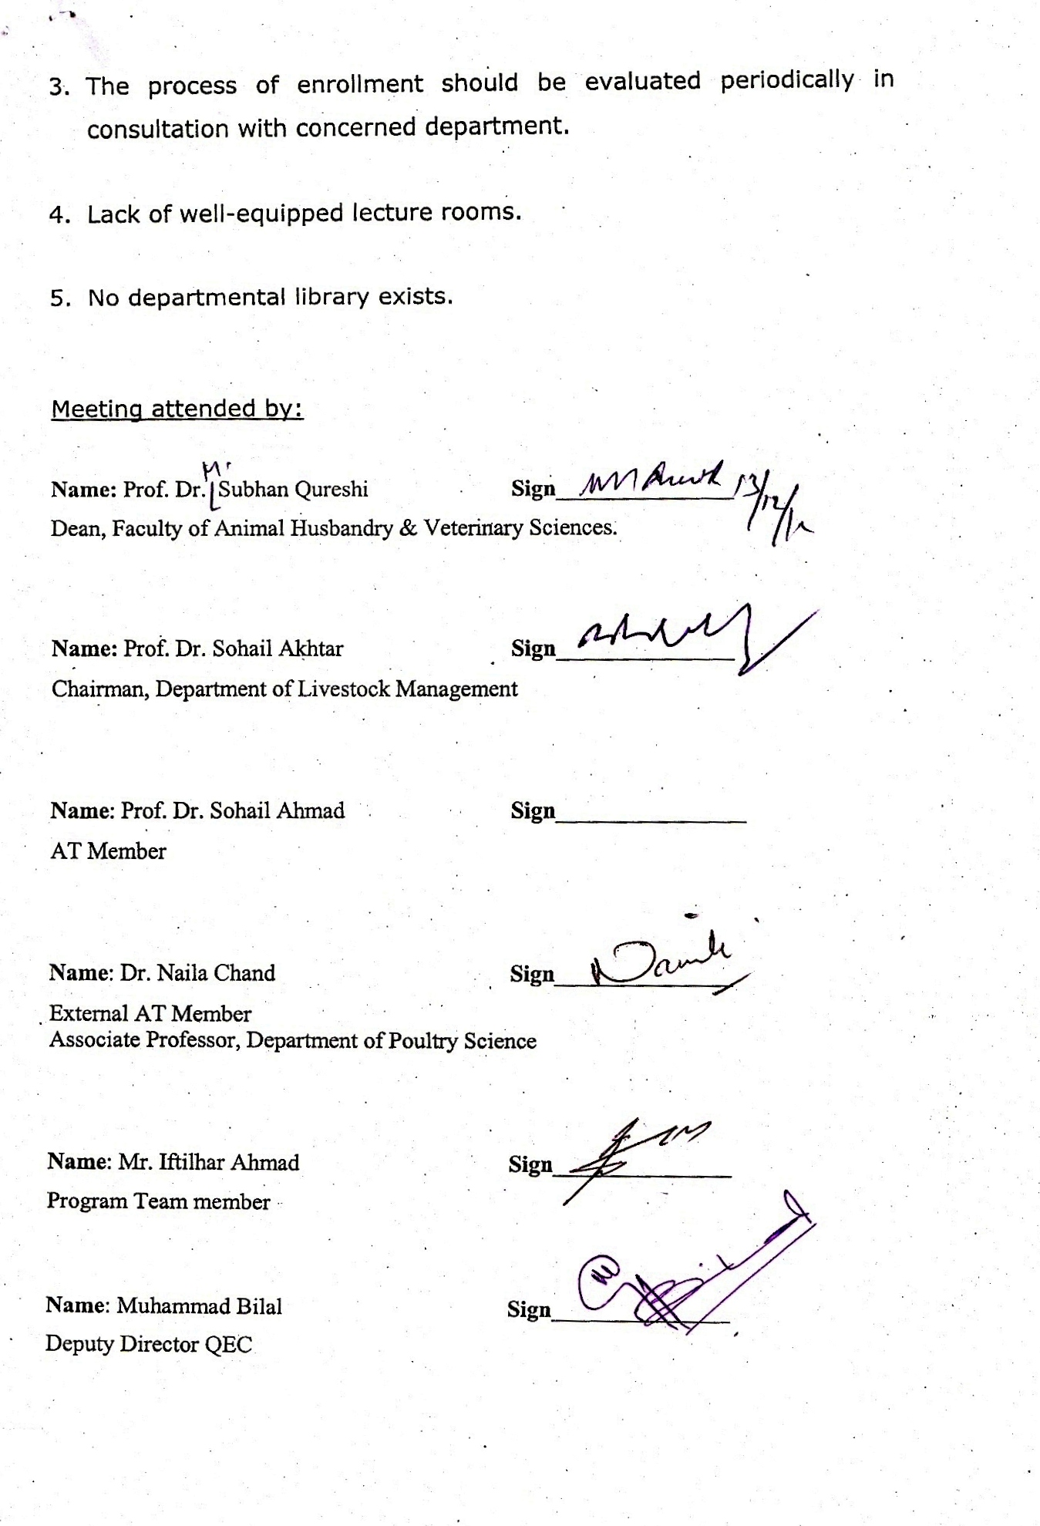

- The process of enrollment should be evaluated periodically in consultation with concerned department.

- Lack of well-equipped lecture rooms.

- No departmental library exists.

Meeting attended by:

Name: Prof. Dr. Subhan Qureshi Sign_______________
Dean, Faculty of Animal Husbandry & Veterinary Sciences.

Name: Prof. Dr. Sohail Akhtar Sign_______________
Chairman, Department of Livestock Management

Name: Prof. Dr. Sohail Ahmad Sign________________
AT Member

Name: Dr. Naila Chand Sign_______________
External AT Member
Associate Professor, Department of Poultry Science

Name: Mr. Iftilhar Ahmad Sign_______________
Program Team member

Name: Muhammad Bilal Sign_______________
Deputy Director QEC

